SMART ALCOHOL INTOXICATION DETECTION AND PREVENTION SYSTEM USING AI
Methodology, Novelty and Key Contributions
Department of Computer Science and Engineering, TKR College of Engineering and Technology (Autonomous)
Batch A6 (CSE-A) · Academic year [ACADEMIC YEAR]
Table 1: Project team
S.No. | Student name | Roll number
1 | B PRANITHA | 23K91A0522
2 | BANTU KAVYA | 23K91A0531
3 | DASARI VIVEKA SARVESHWARI | 23K91A0560
4 | BEKKAM VAMSHI | 23K91A0534

Project guide: N. PADMAVATHI
Chapter and section numbers quoted in the text (for example Section 6.6 or Chapter 8) refer to the full project report, 17.Final Document. Figures and tables in this document are numbered from 1.

1. OVERVIEW OF THE METHODOLOGY
This document describes how the system works from end to end and what is new in it. Part 1 gives the pipeline, the data, the algorithms and the reasons they were chosen; Part 2 sets the work against the base paper and separates what is new from what is standard; Part 3 lists the contributions.

6.1 Overall methodology
The work has two parts that share the same measurement code. In the runtime pipeline, a frame from the webcam (or a scripted simulation sample) is checked for image quality, a pre-trained face landmark model locates the eyes, the eye aspect ratio and head roll are computed, and a transparent rule engine turns the last few seconds of measurements into one of three answers: Normal, Possible impairment or drowsiness, or Unable to assess. In the evaluation part, the components of that pipeline are measured separately on the data that exist: the eye-state decision on a public dataset of open and closed eyes, the image-quality checks on deliberately degraded images, the rule engine on scripted measurement streams, and the speed of the whole path. An offline research pipeline for a consented, labelled study is also provided, but no real study data exist yet.
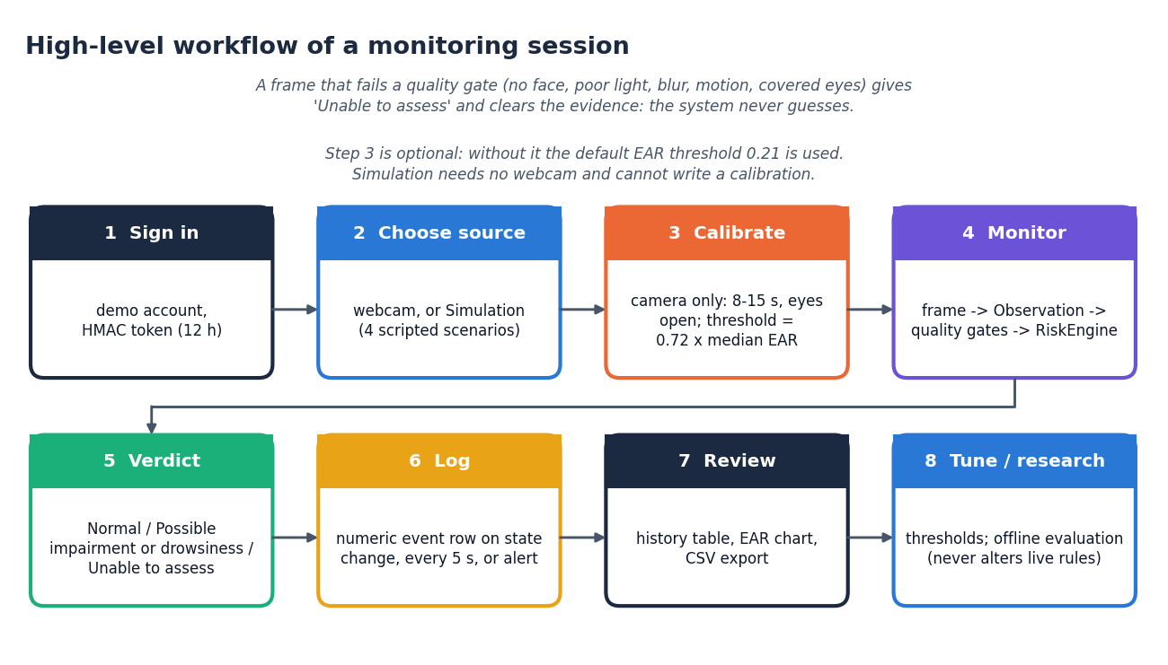
Figure 1: Overall workflow of the runtime pipeline
This is a deliberate narrowing of the batch's original aim. The abstract speaks of classifying a driver as Safe or Intoxicated with a deep-learning model and of a prevention action such as an ignition warning. We found no dataset of intoxicated and sober people that could be used (Section 6.2), a camera cannot establish alcohol consumption, and a classifier trained without such data would have produced numbers with no meaning. We therefore built an explainable drowsiness and impairment warning from observable eye and head cues, kept the objectives that could be met honestly and recorded those that could not (Chapter 9).

6.2 Data used and not used
No dataset of intoxicated people was used, and no intoxication accuracy is claimed anywhere in this report. The public dataset DIF of perceived intoxicated faces [4] lost many of its source videos, as the authors of the base-paper companion study note [2], who built their own set of 202 people and 3,542 video segments; it is not available to us. The table lists every data source that was used and what each one can and cannot show.
Table 2: Data sources
Source | What it is | Used for | Cannot show
Closed Eyes in the Wild (CEW) | 2,423 face images at 100 x 100 pixels: 1,192 with both eyes closed (collected from the Internet) and 1,231 with eyes open (from LFW) [12], [13] | Measuring how well the six-point EAR separates closed from open eyes in the shipped pipeline; the threshold sweep; the ROC curve | Anything about alcohol, blink dynamics, video, riders, helmets, or sources other than these two
Degraded copies of CEW open-eye faces | 272 faces, each darkened, over-exposed, blurred, noised, covered by an opaque patch over both eyes (sunglasses), a semi-transparent patch (tinted lenses), a patch over one eye, or masked below the nose | Checking that the quality gates fail safe | Real-world lighting, real eyewear or real occlusion; the 100-pixel source images are softer than a webcam frame
Scripted simulation streams | Four scenarios inside core.simulate, and seeded generators in scripts/measure_rules.py | Showing how the rules behave (how long a closure must last, what blink patterns could false-alarm) | Performance on people: the streams are generated, not recorded
Synthetic research CSV | backend/synthetic.py: seeded generator, 6 subjects x 2 labels x 30 s at 10 Hz (3,600 rows) | Demonstrating the offline pipeline end to end (48 training and 24 held-out windows) | Anything: its 100 % scores only prove the code runs, and the interface flags them as Synthetic data
Public-domain portrait | One public-domain face photograph played as the browser's fake webcam | Capturing real screenshots of the camera path and testing the camera API | Detection accuracy: it is one face

The CEW images are used only to measure the pipeline and are not copied into the project folder. Closed-eye pictures come from the Internet while open-eye pictures come from a different, face-recognition collection, so the two classes differ in source and image conditions as well as in eye state; the separation measured on them may therefore be better than within a single source. The images are still pictures: they cannot test blink timing or the persistence rules.
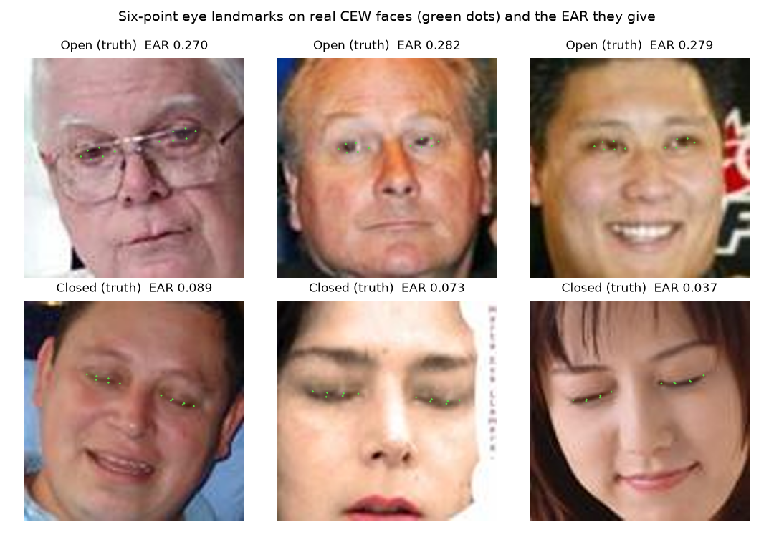
Figure 2: The shipped pipeline on real CEW faces: the six landmark points per eye (green) and the resulting EAR, for open eyes (top row) and closed eyes (bottom row)

6.3 Preprocessing: image-quality checks and landmark geometry
Every frame passes through the same steps, in this order (the pixel checks and the landmark steps are in vision.py). The first checks work on the pixels alone, so a frame that is too dark or too blurred is rejected before any landmark model is run:
1. Resize the frame to 640 x 480 (the camera worker or the session does this before calling Vision.process; the browser already sends frames of this size).
2. Compute the mean grey level of the frame; below 40 or above 225 (on a 0 to 255 scale) the quality label is Poor lighting.
3. Compute the Laplacian variance of the grey image as a sharpness measure; below 25 the label is Blurred or hidden eyes.
4. Compute the mean absolute difference from the previous frame reduced to 96 x 72 pixels; above 35 the label is Unstable video.
5. Run the MediaPipe Face Landmarker [10], [11], [24] in video mode (detection, presence and tracking confidence 0.7, up to two faces). No face gives No face; more than one gives Multiple faces.
6. For each eye take the six perimeter points (left eye landmarks 33, 160, 158, 133, 153, 144; right eye 362, 385, 387, 263, 373, 380). If an eye is narrower than 14 pixels or its patch (with a 6-pixel margin) leaves the image the label is Eyes out of view or too small. If the eye patch has a mean grey level below 35 or above 230, or a standard deviation below 8, the label is Hidden eyes or poor eye lighting.
7. Compute the EAR of both eyes. If they differ by more than 0.12, or either exceeds 0.65, the label is Unreliable eye geometry; otherwise the observation's EAR is their mean.
8. Compute the head roll from the outer eye corners (landmarks 33 and 263) and draw the eye points on the frame for the preview.
These checks are heuristics, not a proof that the eyes are visible: dark or blank visors usually fail them, but patterned occlusions or landmarks inferred for hidden eyes can pass. Chapter 8 measures how they behave under degradation. Two further timing checks are made by the rule engine itself: an observation whose time does not increase, or that arrives more than 0.5 s after the previous one, invalidates the accumulated evidence.
Table 3: Quality labels produced before a verdict
Label | Condition
Poor lighting | Frame mean grey level < 40 or > 225
Blurred or hidden eyes | Laplacian variance < 25
Unstable video | Mean difference from the previous reduced frame > 35
No face / Multiple faces | Landmarker returned no face / more than one face
Eyes out of view or too small | Eye width < 14 px, or eye patch outside the frame
Hidden eyes or poor eye lighting | Eye patch mean < 35 or > 230, or standard deviation < 8
Unreliable eye geometry | Left and right EAR differ by > 0.12, or EAR > 0.65

6.4 Algorithm choice and justification
Table 4: Choices and reasons
Decision | Choice | Reason
Landmarks | MediaPipe Face Landmarker (pre-trained, not trained by us) [10], [11], [24] | Runs on a laptop CPU at 13 ms per frame (median) in our measurement; needs no training data; gives the eye contour points directly
Eye openness | Six-point eye aspect ratio [9] | Dimensionless, so independent of image scale; simple to compute and to explain; the same feature family as the base paper
Noise suppression | Median of the last 3 EAR values | Removes a single outlier frame without the lag of a long average
Decision | Transparent duration rules, not a trained classifier | No labelled intoxication data exist for this project; every warning can be explained by a sentence (closure of 4.9 s, closed fraction 63 % over 10 s); thresholds can be reviewed by the user; unclassified signal is not forced into a class
What is being detected | Sustained eye closure, closed-eye fraction, head tilt with low EAR | These are established drowsiness indicators [15], [16], [28]; they are not specific to alcohol, so the output is named Possible impairment or drowsiness
Personalisation | Calibration: threshold = 0.72 x median open-eye EAR | People differ in natural eye openness; the base paper also personalises its threshold [1]
Safety behaviour | Quality failure always gives Unable to assess and clears the evidence | A wrong Normal is worse than no answer
Offline study tool | Standardised nearest-centroid classifier on 5-second windows, subject-disjoint split | Deliberately simple and auditable; ready for a real consented dataset; never loaded into the live engine

Learned alternatives exist. A recent study on facial video reports 95.82 % accuracy for intoxication with a graph attention network and a 3D ResNet [2], and a smartwatch study reports an AUROC of 0.88 on a test track [3]. Both rely on data collected from people who had drunk alcohol under controlled conditions. We could not reproduce such a study within a student project and did not want to present an unvalidated network as if it had been.

6.5 Mathematical formulation
Eye aspect ratio. For one eye with perimeter points p1 (outer corner), p2 and p3 (upper lid), p4 (inner corner), p5 and p6 (lower lid):
EAR = ( ‖p2 − p6‖ + ‖p3 − p5‖ ) / ( 2 · ‖p1 − p4‖ ) (1)
The observation's EAR is the mean of the left and right values, each computed from landmark coordinates in pixels (so the image aspect ratio is respected). The engine then smooths it with a median over the last three observations:
EARs(t) = median( EAR(t), EAR(t − 1), EAR(t − 2) ) (2)
Closed eye, closure time and blink. An eye is closed when EARs is below the threshold θ (0.21 by default). With t0 the time at which the current uninterrupted closure began:
closed(t) = [ EARs(t) < θ ], closure(t) = t − t0 while closed (3)
A completed closure lasting between 0.08 s and 0.8 s counts as a blink. The blink rate is the number of blinks in the last 60 s divided by the observed good-signal time (capped at 60 s), times 60; it is displayed but never triggers a warning by itself.
Closed fraction. Over the last 10 seconds the fraction is time-weighted, so an irregular frame rate cannot multiply the votes of a closed eye. For consecutive observations i and i + 1 at times ti:
fraction = Σ ( ti+1 − ti ) · closedi / ( tlast − tfirst ) (4)
Head roll. From the outer eye corners (xL, yL) and (xR, yR) in image coordinates, in degrees:
roll = atan2( yR − yL , | xR − xL | ) · 180 / π (5)
This is the tilt of the face in the image plane. It is not a full head pose: it ignores yaw and pitch and depends on how the camera is mounted.
Warning rule. Let R1 = closure ≥ 1.5 s, R2 = (fraction ≥ 0.55 and at least 8 s of history) and R3 = (|roll| ≥ 25° and the eye is closed). An evidence timer starts at the first time any of them is true and is cleared when none is. With at least 2 s of reliable history the answer is a warning when the evidence has lasted the persistence time (1.0 s):
warning(t) = ( R1 ∨ R2 ∨ R3 ) and ( t − tevidence ≥ 1.0 s ) and ( history ≥ 2 s ) (6)
Calibration. During an 8 to 15 second stationary recording only frames of Good quality, EAR between 0.15 and 0.50 and |roll| below 15° are accepted. If at least 40 frames and at least 70 % of all frames were accepted, and the spread is small, the new threshold is:
θ = clip( 0.72 · median(EAR accepted), 0.12, 0.32 ), required: std(EAR) / median(EAR) ≤ 0.15 (7)
Offline metrics. For the research pipeline and for our measurements, with TP, FP, FN and TN counted for the closed (or impaired) class:
precision = TP / (TP + FP), recall = TP / (TP + FN), specificity = TN / (TN + FP) (8)
F1 = 2TP / (2TP + FP + FN), accuracy = (TP + TN) / (TP + TN + FP + FN), false-alarm rate = FP / (FP + TN) (9)
ROC analysis [25] and the area under the curve (AUC) summarise how well EAR alone ranks closed eyes below open eyes over all thresholds, and the metric definitions follow [26]. The false-alarm rate of the research tool is per test window, not per hour of riding.

6.6 Model architecture and what 'training' means here
There is no trained model in the decision path. The only learned component is Google's pre-trained Face Landmarker, which we use as a geometry tool: it returns 478 facial landmark coordinates and was neither trained nor fine-tuned by us. It does not know about drowsiness or alcohol. Everything after it is a rule engine.
The rule engine is a small state machine with three outputs. It starts in Unable to assess (warm-up) and needs 2 seconds of continuous good observations before it may say Normal. From Normal, the first time a rule is satisfied starts the evidence timer; the answer changes to the warning only after the persistence time, and returns to Normal when the rules clear. Any quality failure, timing gap or invalid value resets the machine to Unable to assess.
Table 5: States and transitions
From | Event | To
Any state | Quality label other than Good, timing gap > 0.5 s, non-finite value, EAR outside 0 to 0.65 | Unable to assess (evidence cleared)
Unable to assess | Less than 2 s of reliable history | Unable to assess (reason: gathering observations)
Unable to assess | 2 s of reliable history and no rule satisfied | Normal
Normal | A rule satisfied (timer starts) | Normal, reason marked 'persistence pending'
Normal | A rule satisfied for the persistence time (1.0 s) | Possible impairment or drowsiness (alert if the cooldown of 15 s has passed)
Possible impairment or drowsiness | No rule satisfied | Normal

What is learned or fitted, and on what, is therefore limited to the following, and each item is stated with its data:
Table 6: Fitted or evaluated elements
Element | Fitted or evaluated on | Status
Per-rider EAR threshold | 8 to 15 s of the rider's own open-eye frames (calibration) | Implemented and exercised with a real face; the stored value 0.183 appears in the screenshots
Default rule constants (0.21, 1.5 s, 1.0 s, 0.55, 25°, 15 s) | Engineering choices, not tuned on data | Left unchanged; the threshold sweep in Chapter 8 was run afterwards and suggests a lower EAR threshold (about 0.17) separates CEW images better, but it was chosen on those same images
Nearest-centroid classifier | Subject-disjoint 5-second windows of a consented CSV | Pipeline tested only on the seeded synthetic CSV (20 unit tests include it); status Model not trained for real data
EAR eye-state check | 2,423 CEW images, evaluation only | AUC 0.993 with the gates and 0.989 without them (Chapter 8)

6.7 Relation to the base paper's method
The base paper [1] builds an adaptive driver monitoring system that fuses an eye feature, head pose and voice intent with a Fuzzy Belief Rule-Based engine [30] and runs on a Jetson Orin Nano. Our work takes its general idea (an eye-aspect-ratio signal, a personalised threshold and a rule-based decision) and differs in these ways.
Table 7: Comparison of methods
Aspect | Base paper | This project
Eye feature | EAR-4 from four upper-lid points, compared with the six-point EAR | The conventional six-point EAR only
Decision | Fuzzy Belief Rule-Based inference over EAR, head pose and voice | If-then duration rules over EAR, closed fraction and image-plane roll
Voice | Whisper-tiny wake words and commands [29] | None
Personal threshold | Initialisation phase on more than 300 frames | 8 to 15 s, threshold = 0.72 x median EAR
Target | Drowsiness, fatigue and distraction | Possible drowsiness or impairment; not alcohol
Hardware | Jetson Orin Nano (8 GB), 25 frames per second | Laptop CPU; about 30 frames per second sustained by the API in our measurement

We did not reproduce EAR-4, the fuzzy belief engine or the voice interface, and no figure of the base paper is attributed to this project.

2. NOVELTY AGAINST THE BASE PAPER
The base paper [1] is an embedded driver-monitoring study that combines a new eye feature (EAR-4), head pose and a voice interface in a fuzzy belief rule-based engine. This project does not reproduce it and does not try to beat its numbers; its contribution is of a different, more modest kind. The table separates what is new in this work from what is standard practice that it reuses.
Table 8: Novelty against the base paper
Aspect | Base paper | This project | Novel here?
Target | Drowsiness, fatigue, distraction | Drowsiness-type impairment indicator for a two-wheeler rider; explicitly not alcohol | Different framing; no new detection capability
Decision logic | Fuzzy belief rule base fusing EAR-4, head pose, voice | Transparent duration rules with persistence, a reason string and quality precedence | Simpler; the explainability and the refusal to guess are the point
Signal quality | Not the focus | Seven quality gates; Unable to assess as a first-class output; gate behaviour measured under degradation | Yes for this project
Personalisation | Adaptive threshold from over 300 frames | Calibration with acceptance tests (>= 40 frames, >= 70 % accepted, low variance) and a clipped 0.72 x median rule | Comparable idea, different recipe
Delivery | Jetson Orin Nano, buzzer | Desktop app and a FastAPI + React web app sharing one core, demo login, history, CSV export, threshold editor | Yes: a reusable software layer
Evaluation honesty | NTHU-DDD frame classification | Eye-state component on CEW with and without gates; degraded-condition test; scripted-stream study of the rules; synthetic results flagged | Yes: measured limits are reported
Offline learning | Random Forest and XGBoost on EAR features | Subject-disjoint window evaluation with a nearest-centroid model, never used live | Pipeline only; no real-data result
Voice, EAR-4, fuzzy engine | Core of the paper | Not implemented | Not reproduced

What is not new. Six-point EAR [9], MediaPipe landmarks [10], [11], closed-fraction ideas related to PERCLOS [15], blink-rate fatigue cues [16] and subject-wise evaluation are established. The project's value lies in assembling them into one inspectable, tested system and in stating its measured behaviour: an EAR ROC AUC of 0.989 on public data, a default threshold that is too conservative, gates that fail safe but strictly, and a warning that needs about 2.5 s of closure.

3. KEY CONTRIBUTIONS
The contributions of the project, in order of importance:
1. An explainable, quality-gated rule engine for eye closure and head tilt with three outputs, a reason for every verdict, evidence persistence, a cooldown and personal calibration (core.py).
2. A complete software layer around it: a MediaPipe vision module, a Tkinter desktop application, a FastAPI service and a React interface with demo login, history, thresholds and research screens, all sharing the same modules.
3. A measured characterisation of the eye-state component on 2,423 public face images: ROC AUC 0.989, and the finding that the default threshold of 0.21 is conservative while about 0.17 separates better.
4. A measured characterisation of the quality gates under software-degraded conditions, showing that they fail safe for darkness, blur and covered eyes but are strict in dim light.
5. A scripted-stream study of the rules (warning latency, false alerts, parameter trade-off) that makes the design consequences, such as the 2.5 s minimum closure, explicit.
6. An offline evaluation pipeline that enforces consent, subject-disjoint splits and window-level metrics, and labels synthetic demonstrations as synthetic.
7. An automated check suite (20 unit tests and 34 API checks) plus reproducible measurement scripts for every number in this report.
8. A plain statement of what was not achieved: no alcohol detection, no deep-learning classifier, no prevention action, no gaze features and no rider study.

